Step -1 https://srivariseva.tirumala.org
First login into website using phone numberwith otp.
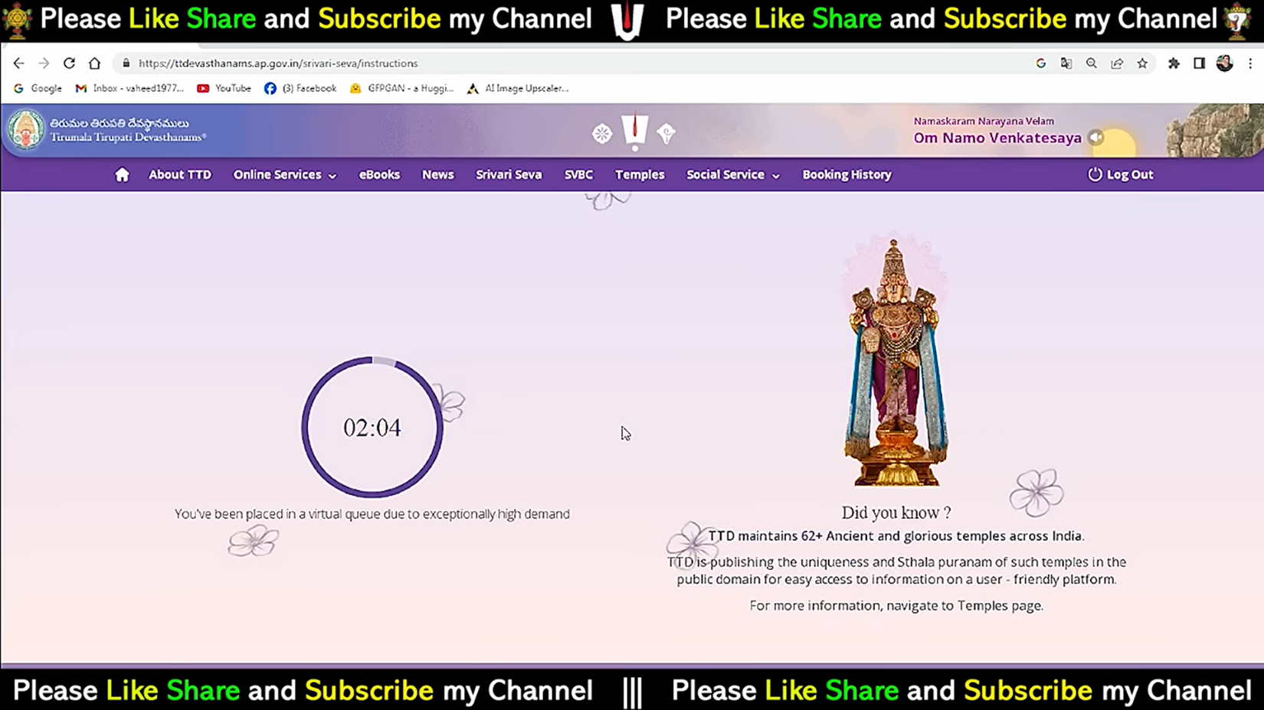
Step-2
After completing the count down. The screen navigate to given below
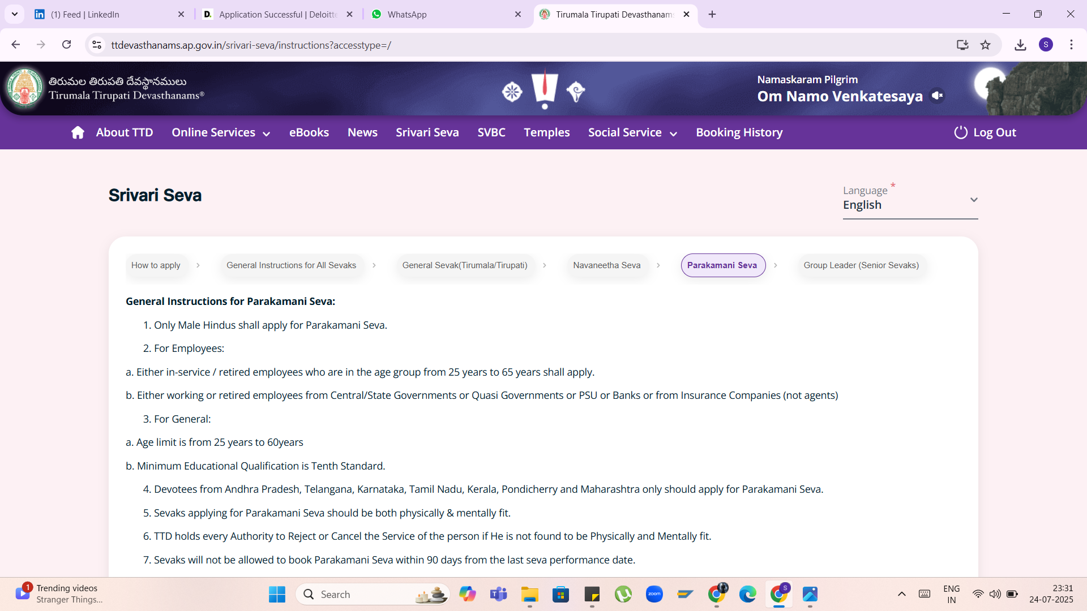

Step 3
After that choose the selected option.
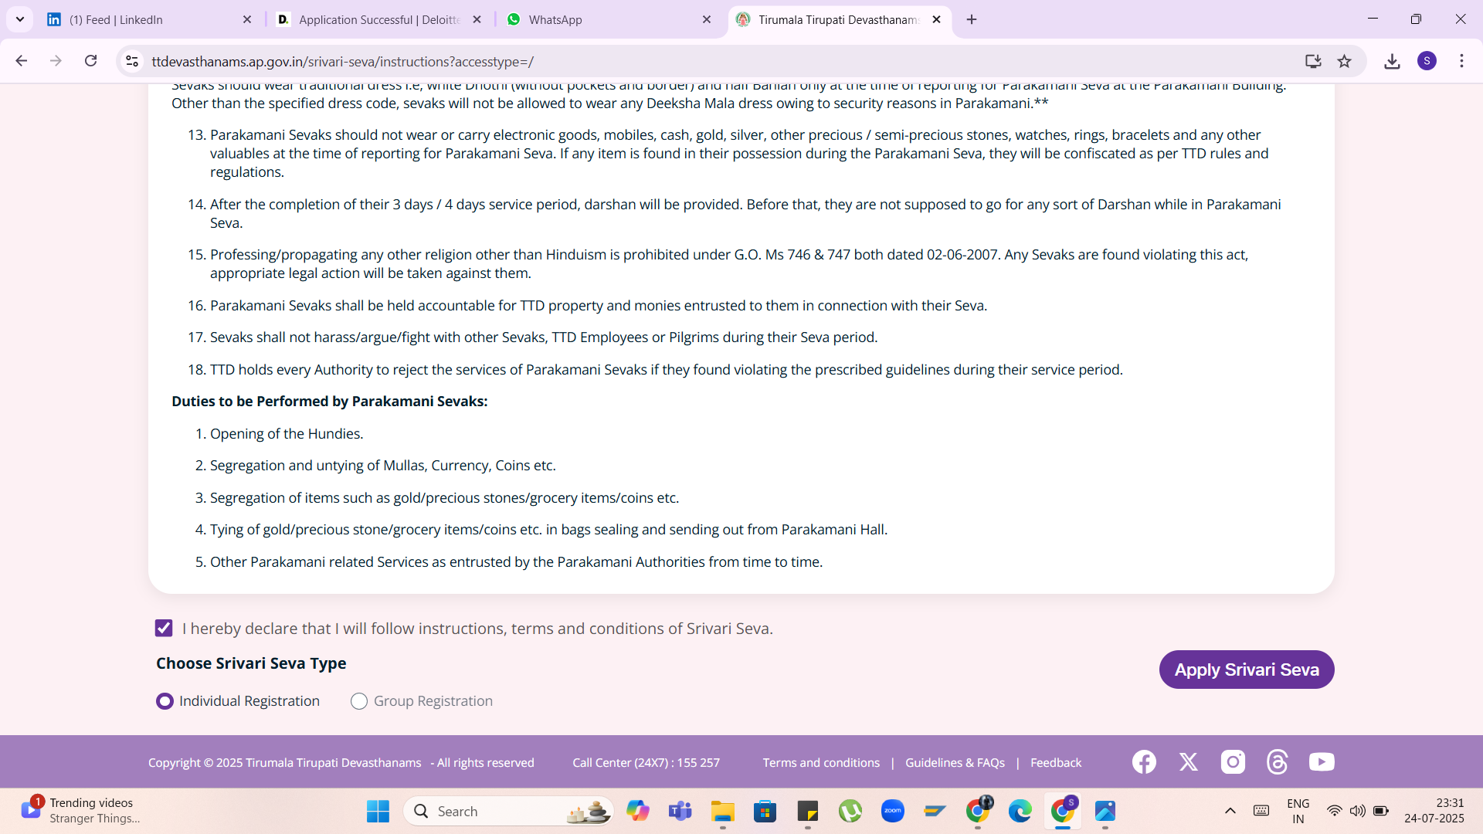
Step 4
After apply the seva the screen navigate to given below.
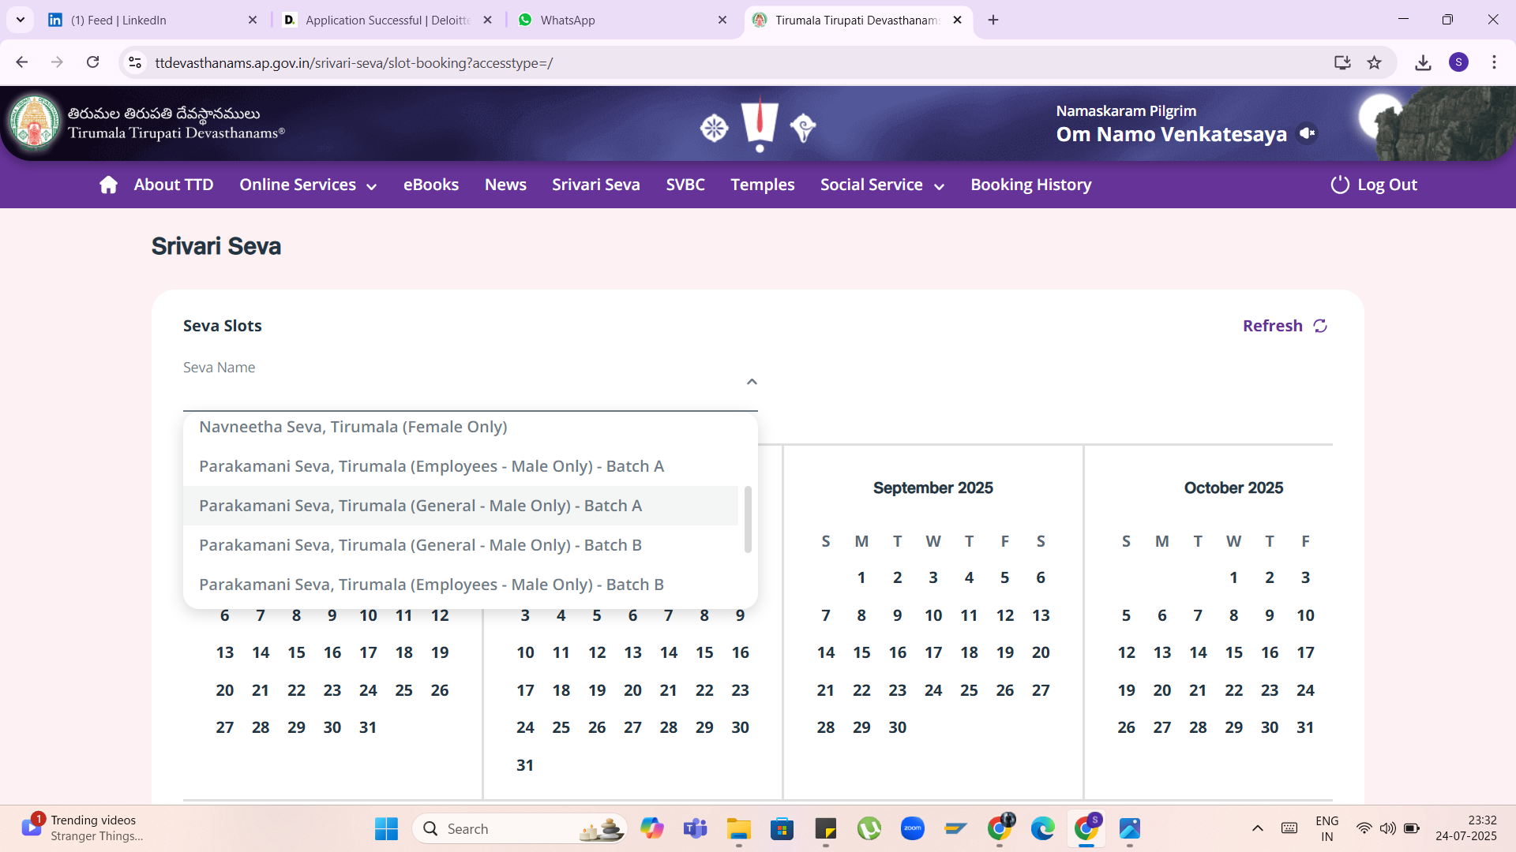
Step 5
Choose the dates of 3 days.
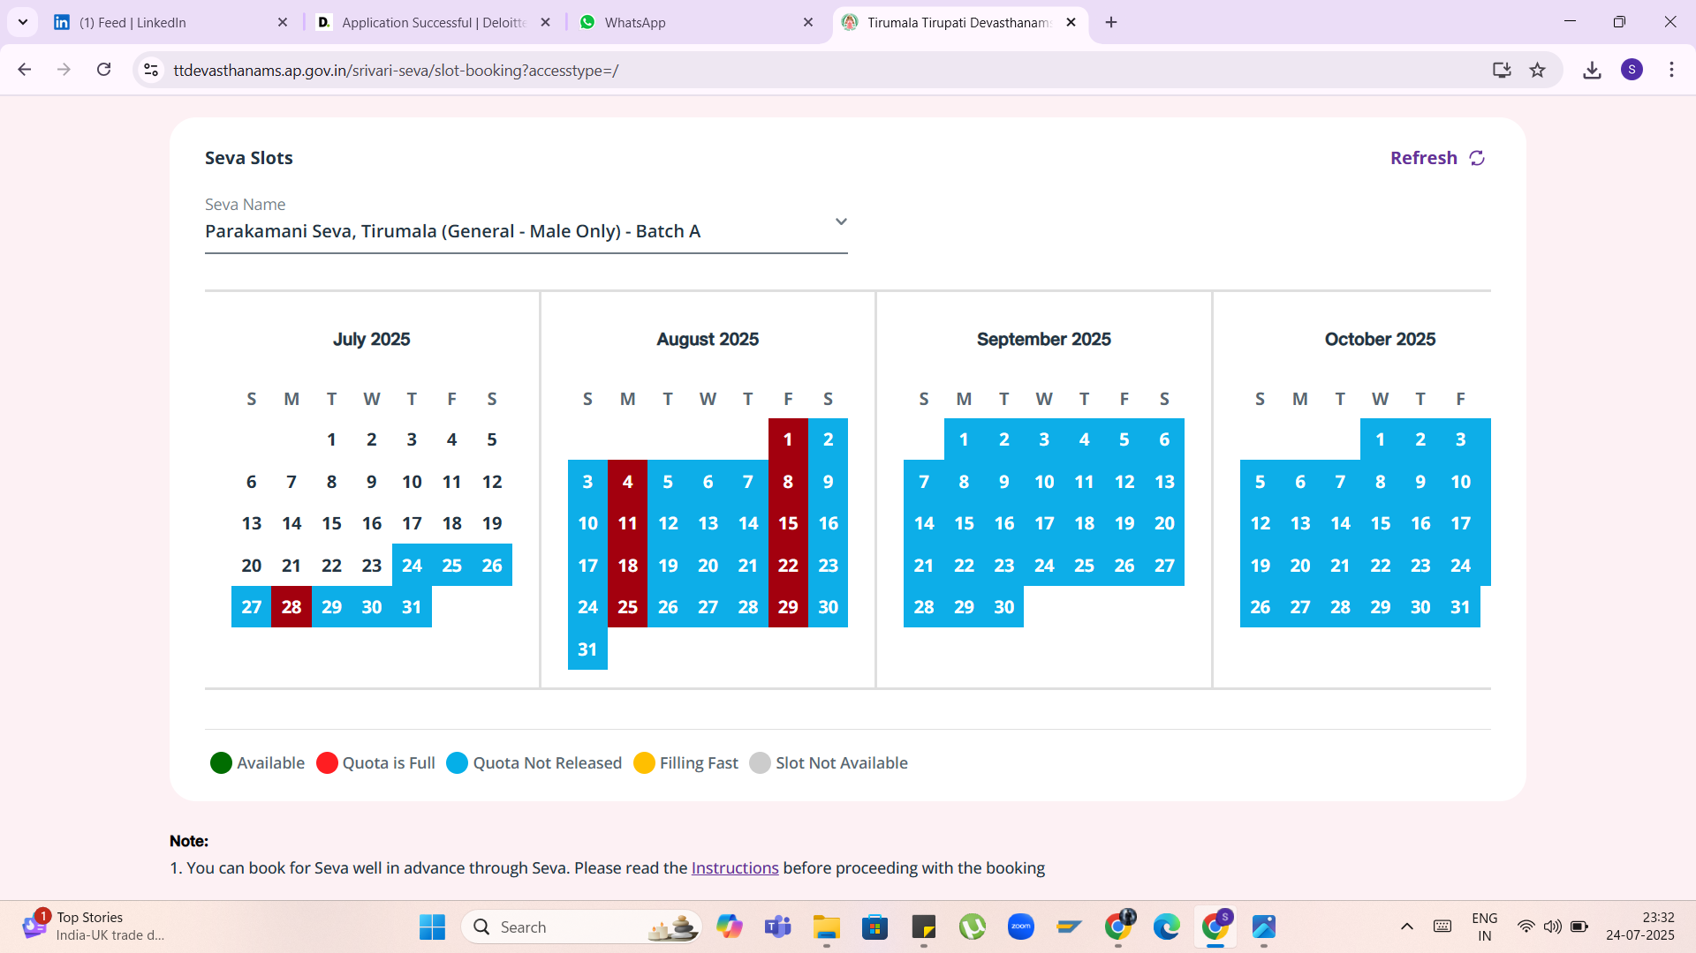
Step 6
After selection of dates click the continue button
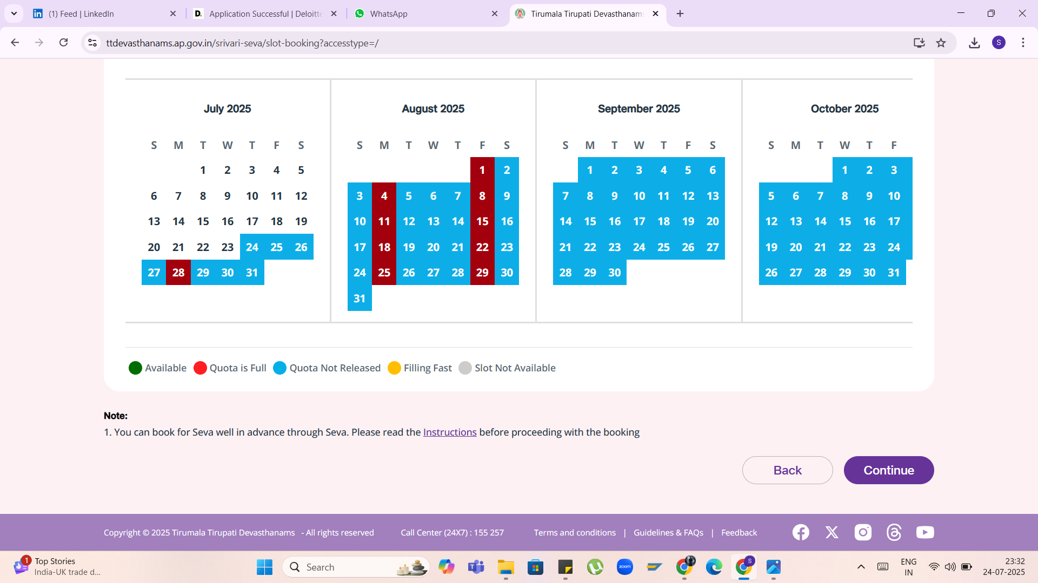
Step 7
- Fill all the mandatory filles
Name, Aadhar number, data of birth, phone number,
- And add the documents Photo jpg, Aadhar jpg, Employee card jpg.
- All fields are filled click the continue button when its directly navigate to the document page.
- Then download the document.

